

|  |  |  |  |  |  |  |  |  |
| --- | --- | --- | --- | --- | --- | --- | --- | --- |
|  | | | | | | | | |
|  | | DB Lab 06 | | | | |  | |
|  |  | | | | | | |  |
|  | | | |  |  | | | |
|  | | | | Basil Ali Khan(20K-0477) |  | | | |
|  | | | | 9 October 2022—Database and Management System Lab—Sir Ahmed Budhi |  | | | |
|  | | |  | | |  | | |

**Exercise#01:**

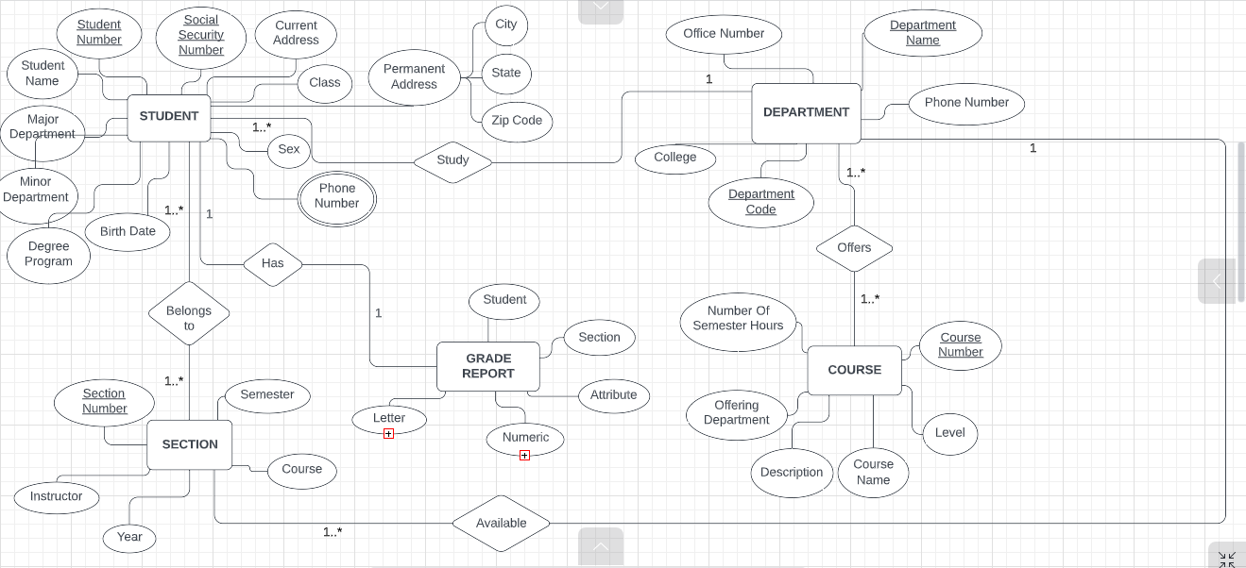

**Exercise#02:**

